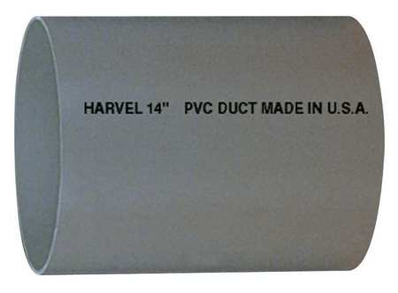
- Pipe, Schedule 80, 6 In, 10 ft. Length, PVC
- HARVEL
- Zoro #: G5276056 Mfr #: H0800600PG1000
- $167.20
In stock
This item ships FREE.

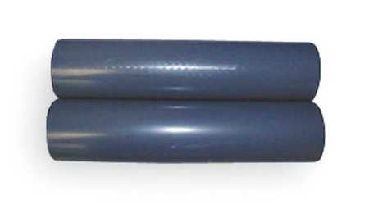
- Pipe, PVC, 4 In, Schedule 80, 10 Feet L
- GF PIPING SYSTEMS
- Zoro #: G3064871 Mfr #: H0800400PG1000
- $82.49
  - Pipe, PVC, 3 In, Schedule 80, 10 Feet L
  - GF PIPING SYSTEMS
  - Zoro #: G1528012 Mfr #: H0800300PG1000
  - $66.72
In stock
This item ships FREE.

Add to Cart

In stock
This item ships FREE.

- Pipe, PVC, 2 1/2 In, Schedule 80, 10 Feet L
- GF PIPING SYSTEMS
- Zoro #: G1367116 Mfr #: H0800250PG1000
- $64.33
In stock
This item ships FREE.

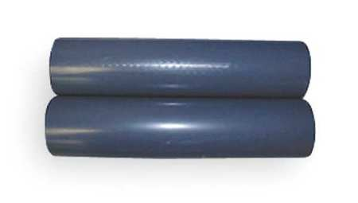
- Pipe, 2 In, PVC, Schedule 80, 10 Ft L
- GF PIPING SYSTEMS
- Zoro #: G2615812 Mfr #: H0800200PG1000
- $23.99
In stock

PVC 80
6” -80 6.625 5.708 0.432 Zoro #: G5276056 Mfr #: H0800600PG1000 $167.20 56 lbs
5” -80 5.563 4.768 0.375
4” -80 4.5 3.786 0.337 Zoro #: G3064871 Mfr #: H0800400PG1000 $ 82.49 29 lbs
3” -80 3.5 2.29 0.276 Zoro #: G1528012 Mfr #: H0800300PG1000 $ 66.72 20
2” -80 2.375 1.913 0.218 Zoro #: G2615812 Mfr #: H0800200PG1000 $ 23.99 10

Orders over $50 ship FREE.
(Make 3 orders to avoid lift gate service )
add aluminum flashing?

Schedule 80 PVC pipe diameters (nested 6”, 5”, 4”, 3”, 2”)
Scale: actual size

dielectric strength of PVC pipe is about 14-20kV/mm
500 kV /`(15kV/mm) = 33.3 millimeters

use aluminum flashing and electrode grading
use refrigeration oil (for dryness)
add Drierite cylindrical shell to core.
various wooden and plastic plugs
calculate capacitance and impedance
Calculated capacitance
Calculated capacitance of one 4 ft active section of 4” dia. Schedule 80 PVC pipe (5 ft total length).

 r = 4.5

A:
(3.14)(3.78)(48) = 570 in2
570 in2 (1 m2/1550 in2)
= 0.368 m2

d:
0.377 in (1m/ 39.4 in)
=9.57 x 10-3 m

Hence:
(8.854×10⁻¹² F m^{–1})(4.5)(0.368/9.57 x 10-3)
=1.53 x 10-12 x 103 Farads
=1.53 x 10-9 Farads

Calculated energy storage at 200,000 volts:
W = 1/2CV2
= (0.5)( 1.53 x 10-9 )(2 x 105)2
= 3.06 x 101
= 30 joules

This is enough energy to light a 30 watt light bulb for 1 second. However, the energy is released as a pulse. If the pulse is 0.1 microseconds long, the instantaneous power level is 300 million watts.

Side view PVC capacitor main tubes
Scale: 1:7

Schedule 80 PVC specs.:
4” 4.5” OD 3.786” ID
3” - 3.5” OD 2.864” ID
2” - 2.375” OD 1.913” ID

60”
12”
10”
14”

15”
.34
stainless steel wool contact

15”
14”
10”
12”

PVC pipe lengths are 60inches; cut from 10 ft lengths; when ordering, group so as to avoid lift gate service charge
Electrode lengths are 40, 36, 32, and 30 inches long. Width to be determined at assembly.
Annulus between 2” and 3” pipe has two electrode surfaces and an annular fill with barium titanate (on-hand) to reduce dielectric stress
Ends are closed with PVC slip caps and dielectric grease. Bottom end has a nylon plug.
Top end has a copper wire sheathed with 3 layers of concentric clear PVC tubing .

End view
Scale: actual size

Aluminum electrode (red)

PCV schedule 80 (blue)
4”
air annulus (white)
3”

2”
Barium titanate filled annulus (orange)

high voltage electrode

Calculated impedance
http://www.allaboutcircuits.com/tools/coax-impedance-calculator/

Where:
Z0 Z0 = characteristic impedance in ohms (Ω)
td td = time delay in nanoseconds per inch (ns/in)
L L = inductance per unit length in nanohenries per inch (nH/in)
C C = capacitance per unit length in picofarad per inch (pF/in)
d2 d2 = inner surface shield diameter
d1 d1 = inner conductor diameter

